Dear __________________ (name of person at the organization),

I am a board-certified Developmental-Behavioral Pediatrician and member of the Society for Developmental and Behavioral Pediatrics (SDBP), an interprofessional medical organization of Developmental-Behavioral Pediatricians (DBPs), psychologists, and advanced practice clinicians who care for children and adolescents with developmental disabilities and behavior disorders.

I am writing you concerning an urgent matter that will negatively impact the field of Developmental-Behavioral Pediatrics and the lives of children with developmental disabilities and their families. DBPs are rigorously trained and certified pediatric subspecialists who evaluate and care for individuals with developmental disabilities and behavior disorders (e.g., cerebral palsy, intellectual disabilities, learning and language disorders, ADHD, autism, Down Syndrome, and more).

The issue:

The Accreditation Council for Graduate Medical Education (ACGME), the body that sets the national standards for U.S. residency training programs, is proposing changes to how pediatric residents are trained to evaluate and care for pediatric patients with developmental disabilities. The proposed changes would remove the requirement for a Board-certified Developmental-Behavioral Pediatrician to teach the pediatric residents, and instead allow pediatric residency program directors to have faculty without specialized DBP training or DBP board certification to teach the residents.

Why this matters:

This critical change in how pediatric residents are trained to care for individuals with disabilities can have serious long-term consequences, such as:
- Decreased quality of the education and training that pediatric residents receive in how to care for disabled children.
- Further reduction of pediatricians who know how to properly evaluate and provide care for disabled children.
- Further decrease in access to care for disabled children and their families

Our stand

The SDBP opposes this change. I am asking that the ___________ (organization’s name) oppose this proposed change in Pediatric Residency education as well.

What you can do

Families and other stakeholders have a time-limited window (until April 5, 2023) to express opposition to the proposed changes and to influence the ACGME to change course. It is to our advantage to get as many people as possible to submit comments on the ACGME website so that public opposition is clear.

Here’s how to comment:

- Go to the ACGME Review and Comment web site: www.acgme.org/what-we-do/accreditation/review-and-comment/
- Scroll down 1/3 of the page to “Requirements for Review and Comment” section and choose Pediatrics (see first image below)
- On the Pediatrics row, click on the table box “Review and Comment Form”

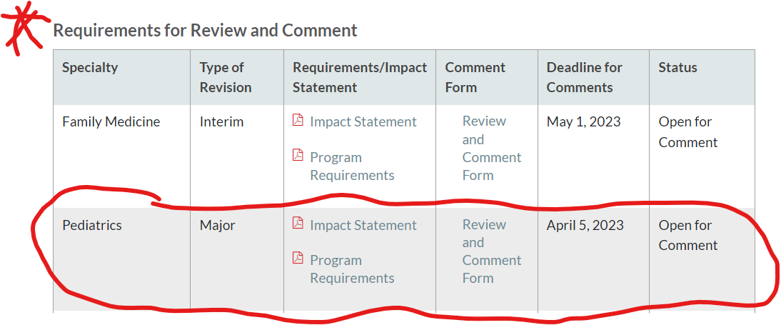

- On the Submit Comment Form (see 2nd image below):
  - On Submission on behalf of drop down menu, select “Member of the Public”
  - On Requirements for comment drop down menu, select Section II.B.1.e).
  - Enter your comments in the box immediately below.

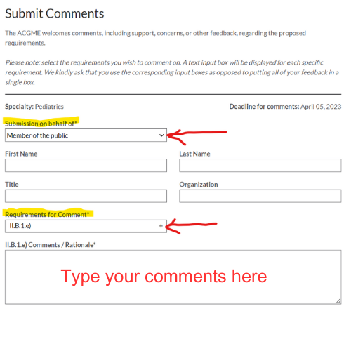
Thank you for considering my concerns and request. Please feel free to share this email with anyone else in the ________ (organization’s name), including any state or local chapters, who may be interested. If you have questions, comments, or concerns, please feel free to contact me.

Sincerely,

