Comment Ideas for Parents and Advocacy Organizations
To post to the ACGME Review and Comment web site
www.acgme.org/review-and-comment/320---pediatrics---major-revision
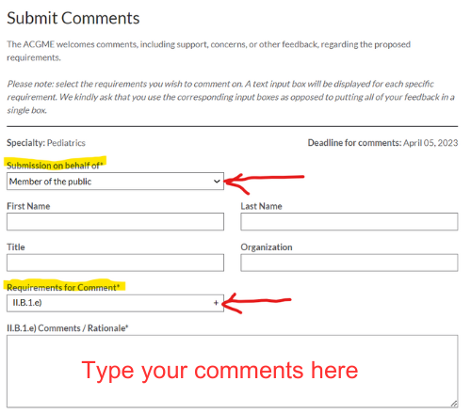
I am a parent/guardian/advocate of a child/for children with __________ (name the disability). I oppose the change to pediatric residency training that the ACGME is proposing.
My child, family, and I rely on having well trained and knowledgeable pediatricians who understand how to address my child’s and family’s needs. If it weren’t for the fact that our pediatrician figured out early on that my son/daughter/child had developmental delays, it would have taken us much longer to get the help and interventions s/he/they needed. We also rely on our Developmental-Behavioral Pediatrician who provides more detailed evaluations and management of my child’s condition.
If pediatric residents will no longer have required training by board-certified Developmental-Behavioral Pediatricians, then I worry that pediatricians will lack the knowledge and skills necessary to care for the children in their practice to have developmental delays, developmental disabilities, and behavior problems. It will be much harder for families like mine to get to the type of medical care our children need.
Please reconsider this change to pediatric residency training and consider alternative methods of having board-certified Developmental-Behavioral Pediatricians train pediatric residents. Our children and families desperately need pediatricians who are very well trained to help our children.

