Comment Ideas for General Pediatricians and other Pediatric Professionals
To post on the ACGME Review and Comment web site
www.acgme.org/review-and-comment/320---pediatrics---major-revision
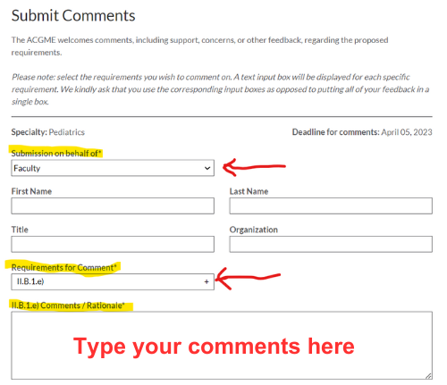
I am a board-certified General Pediatrician/licensed and certified Advanced Practice Clinician/Licensed Clinical Social Worker who cares for many children with developmental disabilities and behavior disorders. I oppose the AGCME’s proposed change to pediatric residency training that removes the requirement for board-certified Developmental-Behavioral Pediatricians (DBPs) to be on faculty. In my clinical experience, Developmental-Behavioral Pediatrics is foundational to pediatric education and pediatric practice. About half of all patient concerns in general pediatric practice deal with concerns for child development, developmental delays, and behavior concerns. We rely on board-certified DBPs to provide us with the expertise in performing a medical evaluation of children we see who have significant developmental disabilities. I worry that removing this training requirement will weaken the quality of pediatric resident training and worsen children’s access to knowledgeable pediatricians who are well trained to care for their needs.
I ask the ACGME to reconsider this proposed change.

