Comment Ideas for Developmental-Behavioral Pediatricians
to post on the ACGME Review and Comment Page
www.acgme.org/review-and-comment/320---pediatrics---major-revision
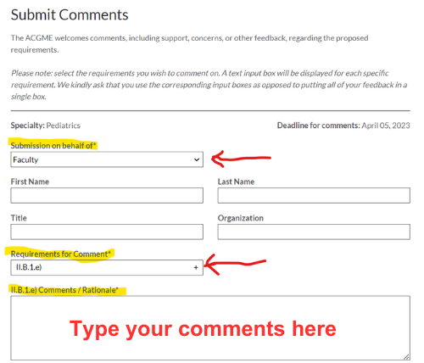
I am a board-certified Developmental-Behavioral Pediatrician (DBP), and I oppose the proposed changes to pediatric residency education that will eliminate the requirement for residency programs to have board-certified DBPs on faculty. Developmental-Behavioral Pediatrics is the foundation of pediatrics.
- This change would remove the quality control standard that Pediatric Residents must be taught the principles and practices of medical evaluation/diagnostic work-up and medical treatment for developmental disorders by individuals who have undergone rigorous and systematic training verified by passing a formal examination.
- The long-term unintended consequence of the ACGME’s change is likely to exacerbate primary care pediatricians’ deficits in the skills needed to: understand the appropriate diagnostic evaluation for children with suspected autism spectrum disorder, developmental disabilities, and other Developmental-Behavioral conditions; serve developmentally disabled children as an adequate medical home; deliver primary care that addresses their unique needs; and collaborate effectively with the specialty services that they require.
- This proposed change will worsen access to and the quality of pediatric care that children with developmental disabilities and behavior disorders receive in the pediatric medical home
- This is a health equity issue that will more significantly impact the lives of disabled children who are from historically marginalized communities, including poor, Black, Indigenous, and other Children of Color, and children from immigrant families.

